Admin Module
1. Menu Name: Group of Company
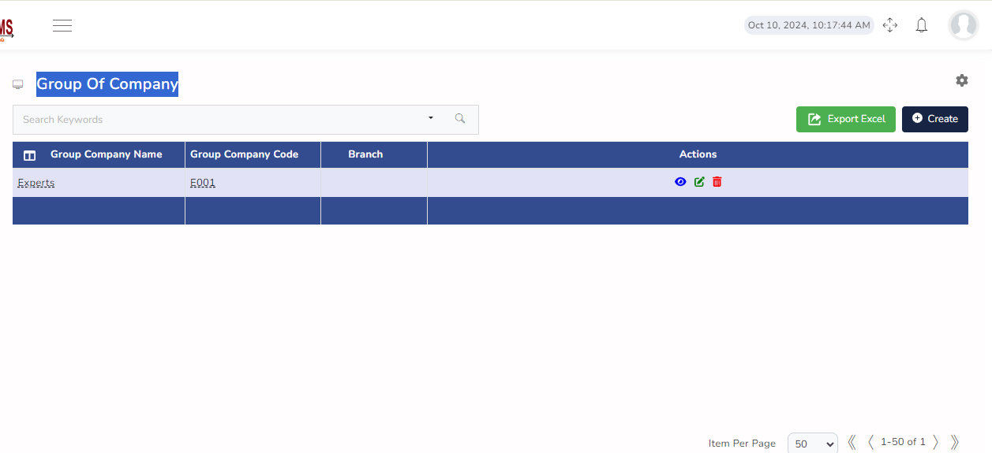
No Changes Required
2. Menu Name: Company
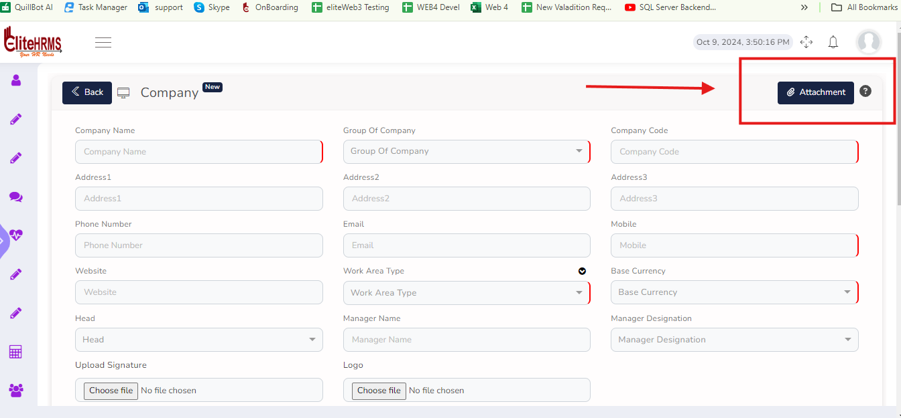
Removed Attachment option

3. Menu Name: Screens
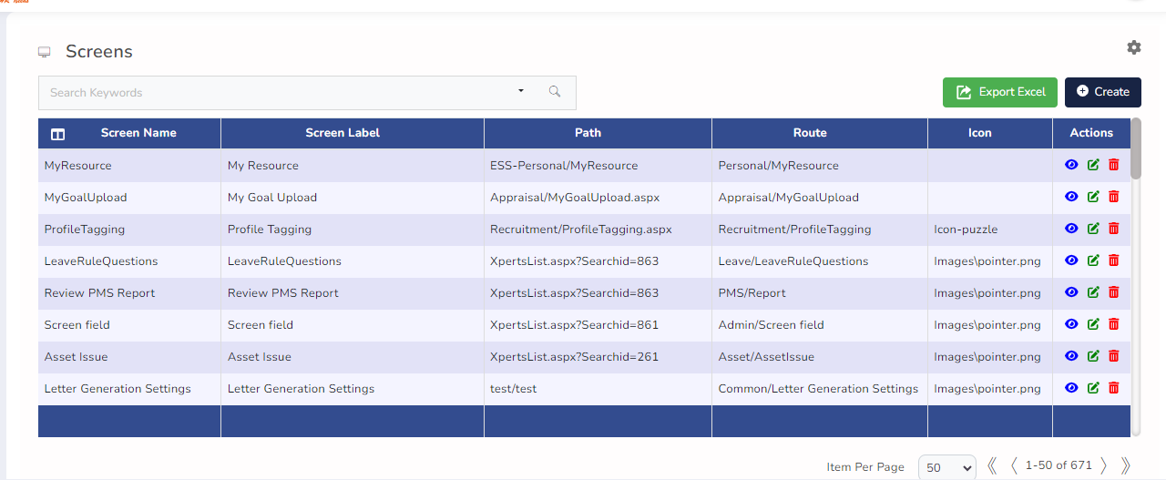
No Change Required

4. Menu Name: Menu Groups
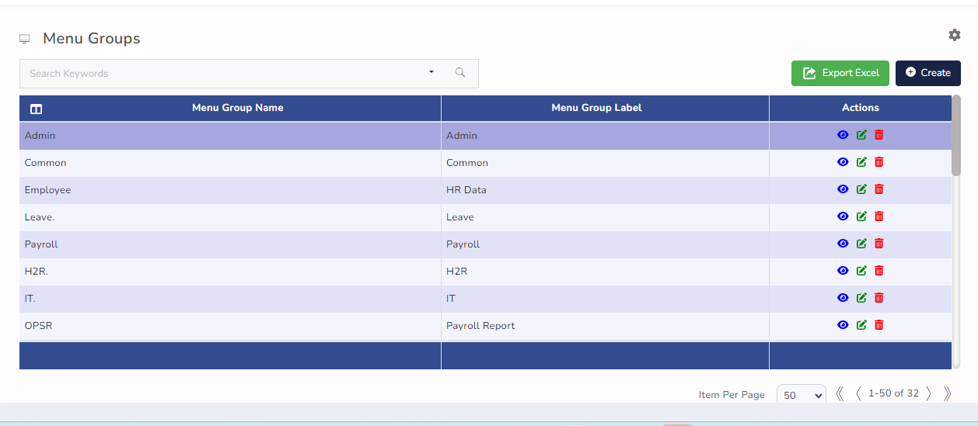

No Change Required

5 Menu Name: Roles
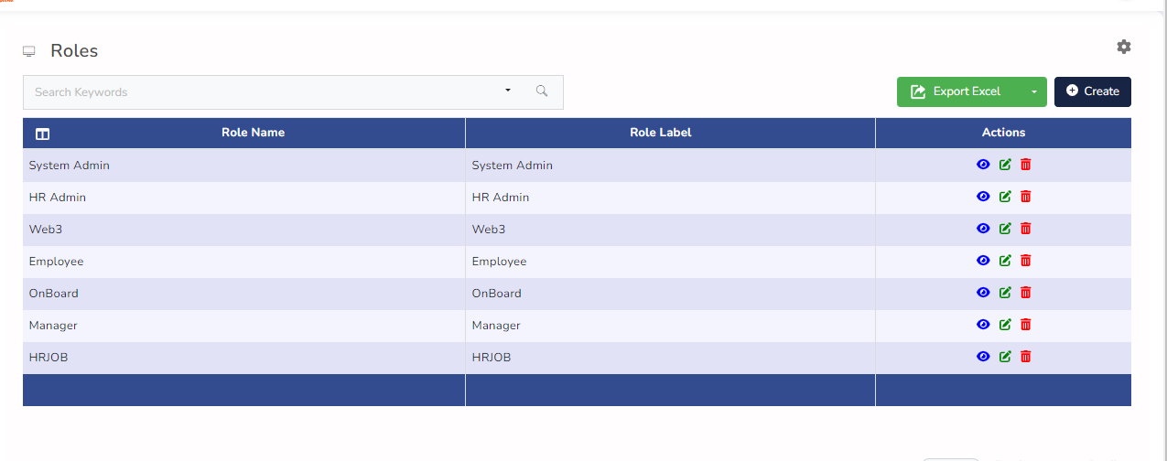
New Option Required: Copy Role Process Option Is Necessary
Example
HR Role Most menu items are necessary for HR executives, but some processes are only deleted for them, therefore role copying is required at that point.

Copy here Note: Parent Details and Child Details also need for Copy

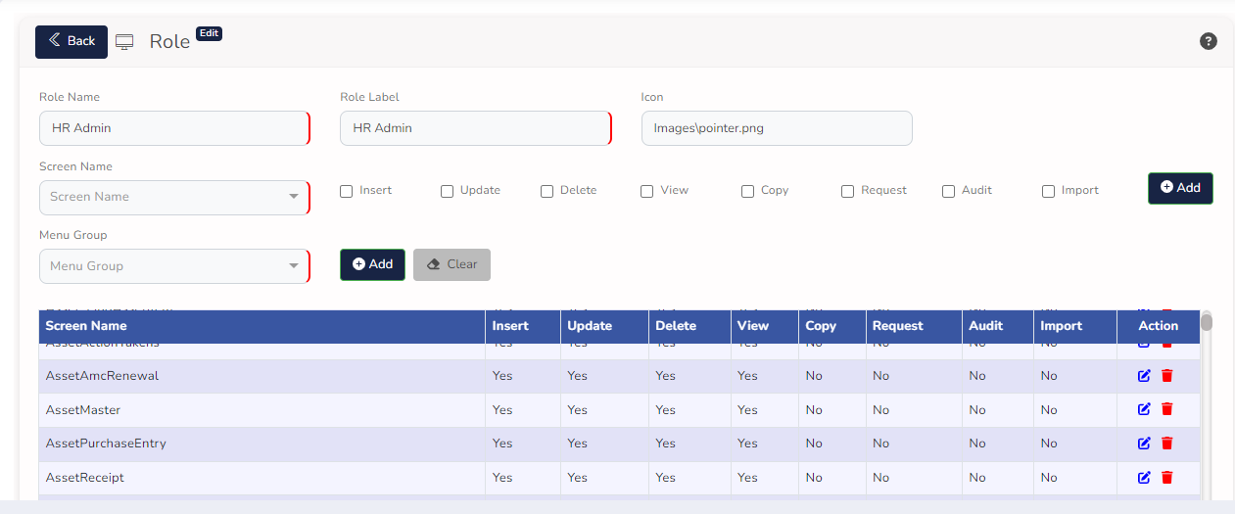

6. Menu Name: Users

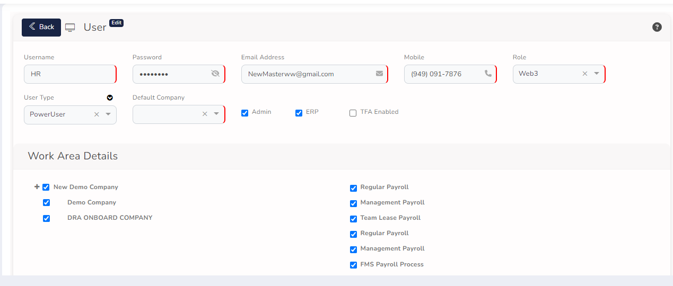

1. TFA Enabled – Default Email id and SMS Sender Required for EliteHRMS Product Name
2. Company Based to load the Pay group details but now All Company’s to load the Pay group details
7. Menu Name: Static code 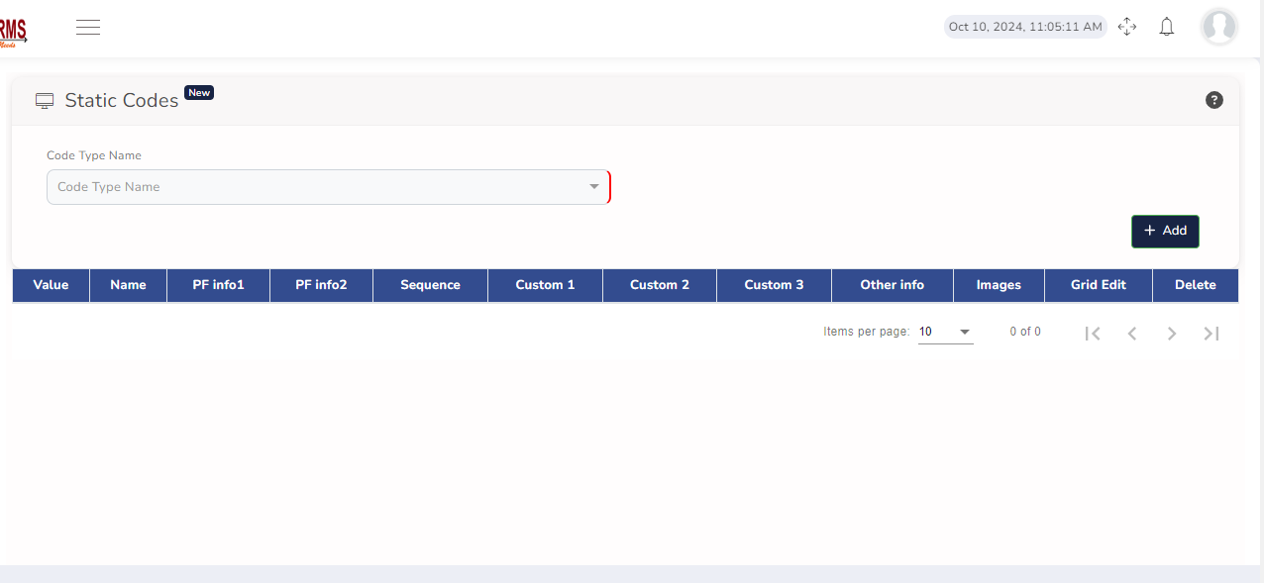

No Change Required

8. Menu Name: Dash Board Items

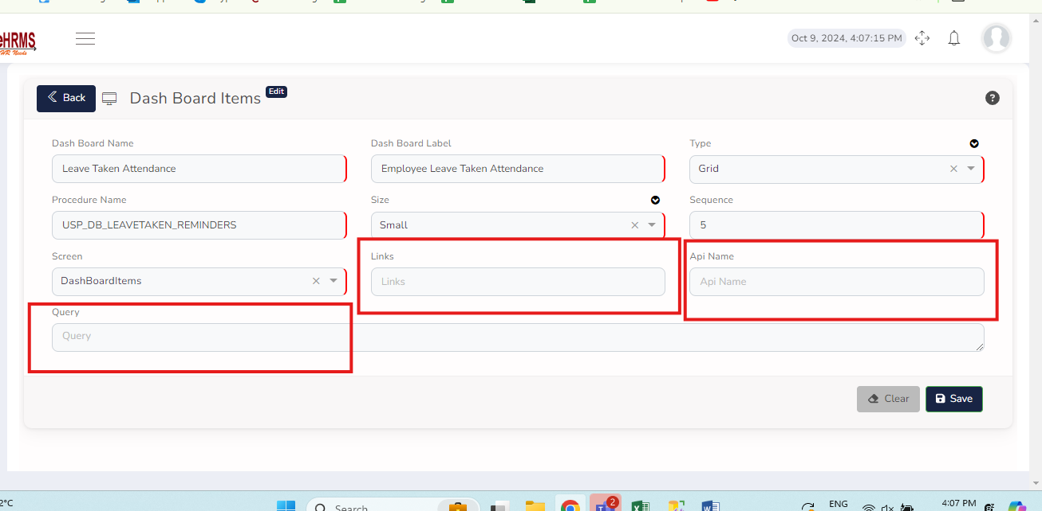

The below input based is not Working in Dashboard Items

- Links
- API Name
- Query

9. Menu Name : Password Policy 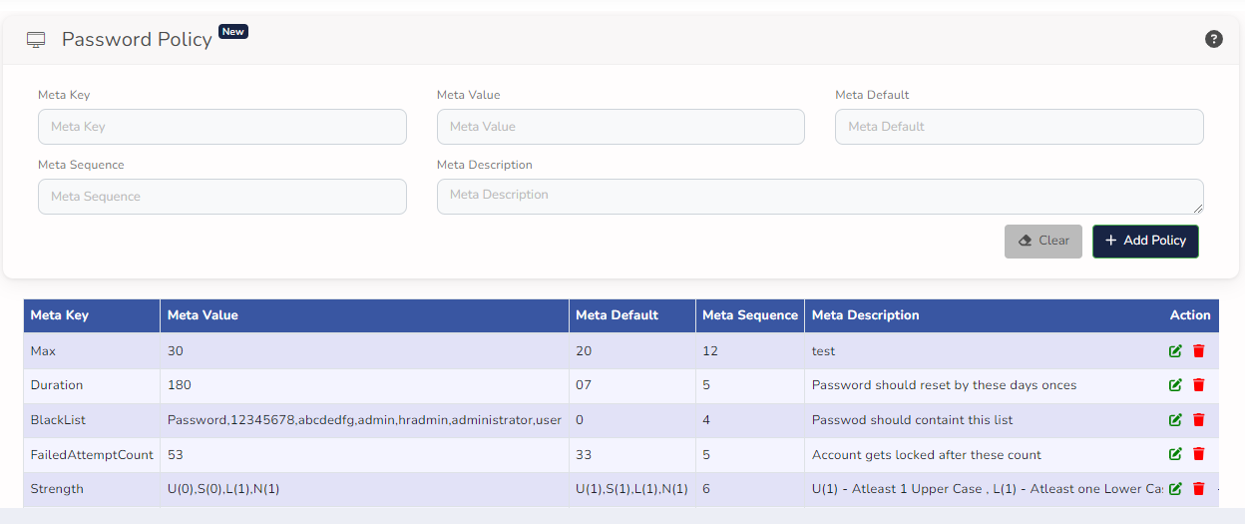
No Change Required

10. Menu Name: Mail Template

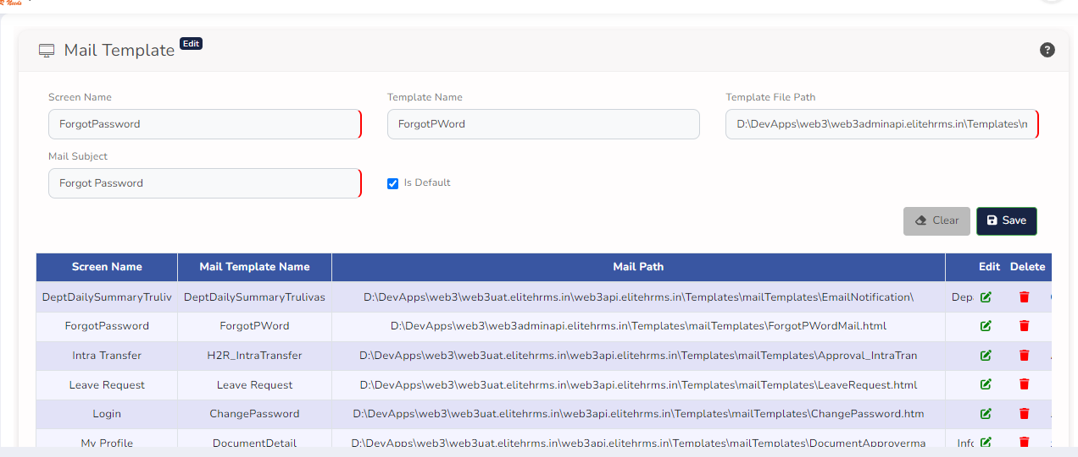

- Template File Path is load From Application Path based

11. Menu Name: System Configuration

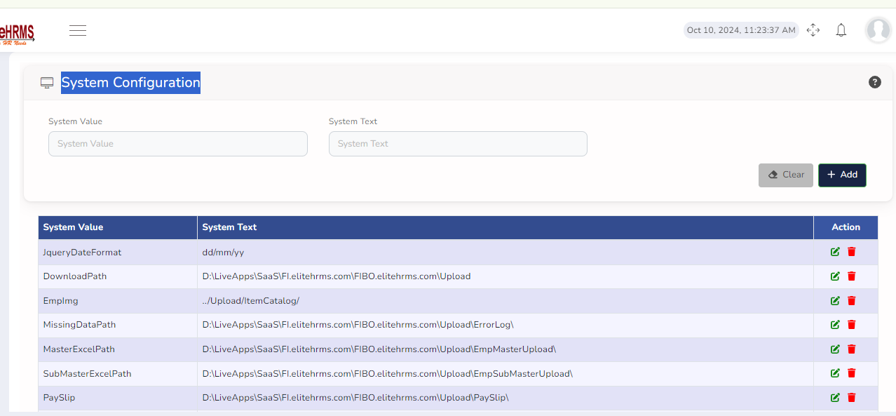

No Change Required

